**PASSWORD PROGRAM: DESIGN BRIEF**

Kyle Christie

[B00415210]

Written 15/11/2021

Finalised 5/12/2021

Lecturer: Joanna Olszewska

Algorithms & Collections



# Overview

Computer users need a secure, reliable yet simple method of managing their personal data. Too easy is it for someone to use the same password for all their online accounts or are clueless to the fact that their data has been breached. The software I propose to create is an attempt to alleviate this issue. This new password program will not only act as a tool to help improve security of login information but ensure there is an awareness of data security.

Password Managers of the current day are too focused on profits and monetisation above anything else. Keeping key features behind pay walls and enforcing limits on those who don’t pay up. I intend to not only make my software accessible for all but provide all features at no extra cost while attempting to improve user knowledge regarding their data.

All features, guaranteed security, improved vigilance for the exact price of absolutely nothing.

**Table of Contents**

​ Overview 2

​ 1. Purpose 4

​ 2. Justifications for using Rapid Application Development 5

​ 3. Requirements 6

​ 4. Further Analysis 10

​ 5. Planned implementation 11

​ 6. Ethics of the project 13

​ Bibliography 14

Table of Figures

Figure 1: MOSCOW Analysis 7

Figure 2: Use Case Diagram 8

Figure 3: Class Diagram 9

Figure 4: Detailed Gantt Chart 12

Figure 5: Simplified Gantt Chart 12

# 1. Purpose

The aims of this software are simple;

* Generate secure passwords
* Easily add your online accounts for safe storage
* Ensure data security and check for vulnerability
* Facilitate a simple, secure and effective method of logging in to your accounts
* Be as accessible to as many demographics as possible

I plan for password generation to create secure data, with little to no chance of identical data being produced and matching general guidelines enforced by online websites and recommendations by experts in the cyber-security field.

Regarding vulnerabilities and data security, I aim to create a facility where users can easily check the status of their data safety by creating some form of integration with reliable sources such as ‘haveibeenpwned.com’ or ‘Firefox Monitor’. I expect that utilising a small selection of these sites will increase reliability in the event that their information may differ.

In terms of ensuring security of the software and related data itself, I will research modern encryption methods, libraries provided by the chosen development environment, additional software at my disposal as well as dedicated software security (which, as an example, may involve some kind of memory protection or similar methods ). This is only a natural approach as the program data will be so sensitive.

In a bid to ensure accessibility, I will attempt to design the front-end of the software with simplicity in mind, specifically in a way that the program won’t be overly complex which may lead to user confusion. I will research other methods of accessibility and design in consideration for those who may otherwise struggle to properly use the software. I expect this to potentially include less complex language and accommodation for assistive technologies alongside other methods..

My hope and overall goal is that the software will be effective in its core functionality (as will be discussed further in this brief) while also containing practical facilities relating to the protection of personal data and fulfilling its secondary goal of informing users on following best practises.

# 2. Justifications for using Rapid Application Development

I have decided to follow one of the many Agile methods, Rapid Application Development. The core reason for this is practicality. I feel that, with this approach, I can focus more time into the research and implementation of the software rather than revisiting various steps that I have already carried out.

With this foundation of prototyping first, I would expect the overall development process to be more swift than, for example, following a traditional waterfall method. If requirements or designs do change from the writing of this brief, I expect that RAD will allow me to effectively adjust to match such new criteria.

I believe that this approach will lead to effective development for myself. I personally place more value in actually creating something and building on that foundation. RAD immediately stood out due to its emphasis on speed and prototyping, as highlighted earlier. It is for these reasons I am confident that my project will benefit from the use of RAD as it intertwines with how I approach software development in my personal projects.

# 3. Requirements

Below are the requirements for the password program. I first carried out MOSCOW Analysis in order to decide which features of the software should be prioritised. This process allowed me to properly decide what can be feasibly implemented during the projects lifecycle.

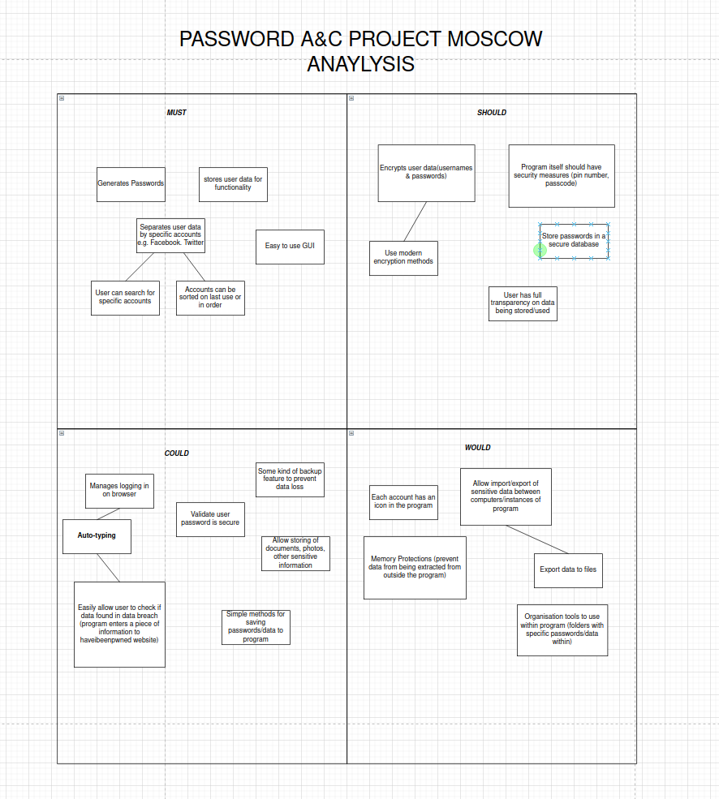Figure 1: MOSCOW Analysis

Next, I created a use case diagram which considers features with the highest priority and how they will be used. This then allowed me to create a class diagram which provides better insight of class layouts.

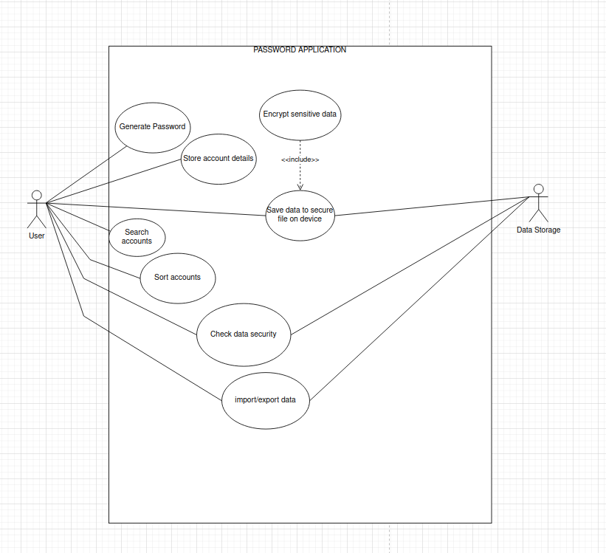Figure 2: Use Case Diagram

Finally, the class diagram. This is the primary blueprint for the classes in the code itself. Containing methods and data that I plan to utilise.

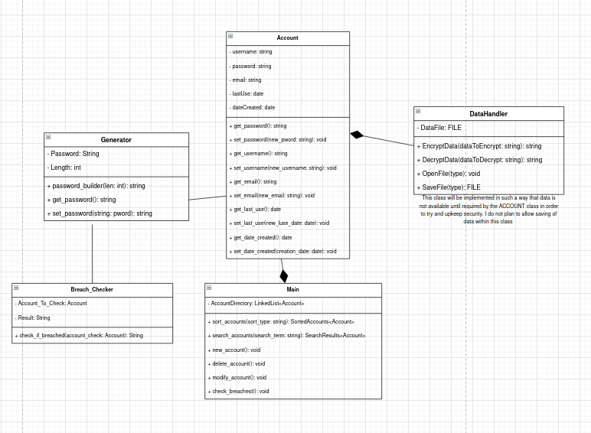Figure 3: Class Diagram

# 4. Further Analysis

The data structure I propose to use in this project is a simple linked list. Given how I wish to allow sorting and searching through accounts, I feel it is the most feasible structure and is best suited to the account functionality of the software. Previous projects which I have worked on have benefited from this combination.

I assume that in storing data, I will be required to use typical security features such as password hashing and salting. Regardless of the method used to store program data, I will have to encrypt it to further ensure security outwith software execution. I believe some form of password or PIN protection may need to be used to protect the program itself. I will need to consider the security of the program code itself and how this can be improved.

# 5. Planned implementation

The programming language I intend to use is C++ with the accompanying IDE being ‘Qt’ developed by the Qt company. The primary reasoning behind my choices is that I desire to gain more experience developing software in C++. Given the various uses of the language, I doubt that this password program will pose no serious issue.

I think the Qt IDE and its accompanying tools and frameworks will act as a great utility for the project. It contains cross-platform functionality which will aid in software accessibility, the software itself will be developed on an Ubuntu Linux workstation but will have assumed availability for any platform supported by Qt. It seems that the IDE provides resources for testing within its labyrinth of development tools which I will be sure to utilise.

*I have considered that in the unlikely event that C++ and Qt are seriously problematic for development or are unviable for the project itself, I plan to substitute them with Java and IntelliJ IDEA. These are tools that I have previous experience with and I’m sure that – should any issues arise – I will be able to quickly reprimand any situation and retain all propositions within this document.*

Within the lifecycle of the project, I will have a dedicated testing phase before finalising the software itself. This will involve Integration, System and Acceptance testing. In essence, ensuring the program itself is indeed a functional product and little to no issues will be encountered upon release to the client or public. During the prototyping stage, I plan to carry out unit testing to focus on ensuring functionality on more specific areas of the code. I will create formal test documentation throughout development including an in-depth test plan. As mentioned earlier in this brief, I also plan to make use of the software testing suite available in the Qt IDE and its tools.

I have taken precautions to protect the project. In the case that my main workstation fails or local data corrupts, I have stored all related files within a GitHub repository. This will allow me to easily access the project on another device and prevent disruption. This GitHub repository will also allow me to easily revert changes and handle version controlling.

Please find below the intended schedule between now (Q4 2021) and the given deadline (Early Q2 2022) in the form of a Gantt chart. One highly detailed with planned tasks and the other simplified to provide a straightforward timeline.

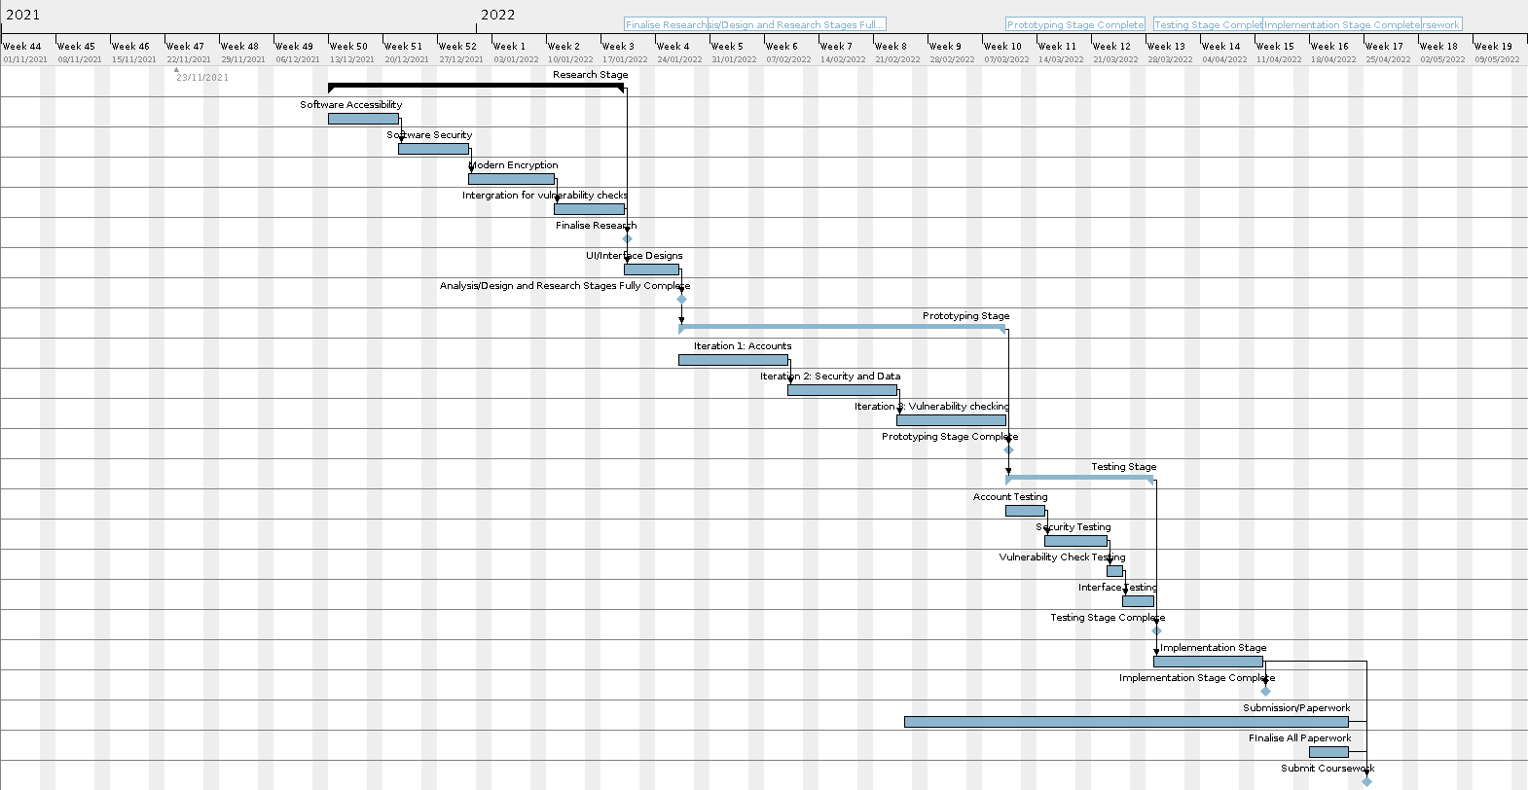Figure 4: Detailed Gantt Chart

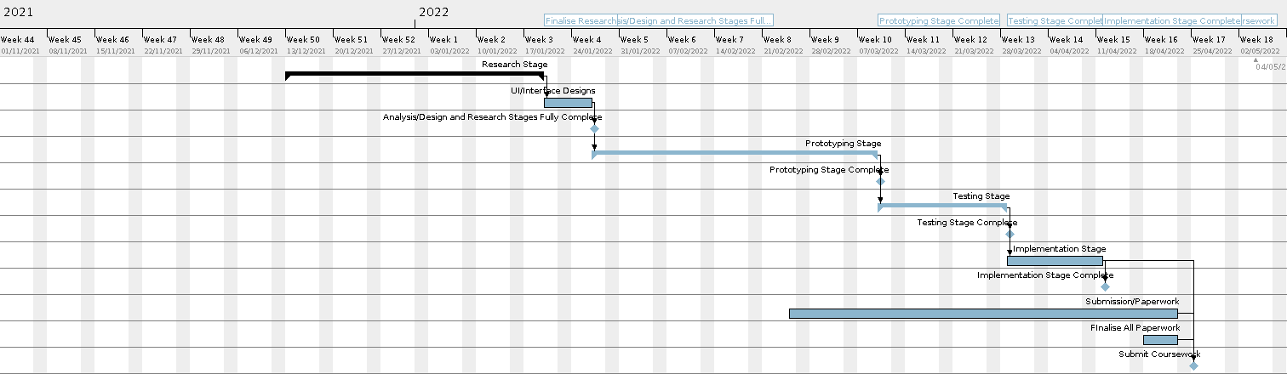Figure 5: Simplified Gantt Chart

# 6. Ethics of the project

In this brief, I have provided significant detail into the intended security of this program. The software will be highly scrutinised with penetration testing and other modern security tests carried out. Regarding data storage, a users data is never intended to leave the system, transmitted to myself or a 3rd party it will always remain on the system where the software installed and will be only accessible to the program itself. I am familiar with relevant law regarding data and computer use, I will ensure that this software complies with the given legislation.

The research I plan to carry out will be in-depth to ensure – completely – that a users security is held to the highest possible standard. The several methods of implementing and testing security mentioned previously further ensure this.

I believe the standard I have set for the implementation of this software, specifically regarding security is to the benefit of the user and with high consideration to not only UK and Scottish law but the codes by which I am bound within my institution. To not have considered this in such detail would instead be a detriment to the user and entirely unethical. I aim to be fully transparent regarding the use of sensitive data and create a functional, useful product.

# Bibliography

National Cyber Security Centre (2021) Password policy: updating your approach [Online] Available: <https://www.ncsc.gov.uk/collection/passwords/updating-your-approach> [Accessed 13 November 2021]

Jancis, M. (2021) How do password managers work? [Online] Online: Cybernews. Available: <https://cybernews.com/best-password-managers/how-do-password-managers-work/> [Accessed 13 November 2021]

LastPass (2021) Plans & Pricing [Online] Available: <https://www.lastpass.com/pricing>[Accessed 14 November 2021]

Dashlane (2021) Plans [Online] Available: <https://www.dashlane.com/plans>[Accessed 14 November 2021]

NordPass (2021) Pricing [Online] Available: <https://nordpass.com/plans/>[Accessed 14 November 2021]

Reichl, D. (2021) KeePass Features [Online] Available: <https://keepass.info/features.html>[Accessed 14 November 2021]

KeePassX Team (2021) Features [Online] Available: <https://www.keepassx.org/features>[Accessed 14 November 2021]

Hunt, T. (2021) have I been pwned? [Online] Available: <https://haveibeenpwned.com/> [Accessed 16 November 2021]

Mozilla (2021) Firefox Monitor [Online] Available: <https://monitor.firefox.com/> [Accessed 16 November 2021]

Burgstahler, S. (2014) Designing Software that is Accessible of Individuals with Disabilities [Online] Seattle, Washington: DO-IT. Available: <https://www.washington.edu/doit/designing-software-accessible-individuals-disabilities> [Accessed 17 November 2021]

Praxent (2019) Digital Accessibility Standards Checklist: Is Your Software Accessible Enough? [Online] Austin, Texas: Praxent. Available: <https://praxent.com/blog/digital-accessibility-software-checklist> [Accessed 17 November 2021]

The Qt Company (2021) Qt home page [Online] Available: <https://www.qt.io/> [Accessed 17 November 2021]

The Qt Company (2021) Cross-platform framework and tools [Online] Available: <https://www.qt.io/product>[Accessed 17 November 2021]

The Qt Company (2021) Products & Features [Online] Available: <https://www.qt.io/product/features>[Accessed 17 November 2021]